Date: June 28, 2024

Early Notice and Public Review of a Proposed Activity in a 100-Year and 500-Year (FFRMS) Floodplain and Wetland

To: All interested Agencies Groups and Individuals

This is to give notice that HUD under part 50 has determined that the following proposed action under an Economic Development Initiative – Community Project Funding (CPF) grant (HUD grant number B-22-CP-AL-0014) is located in the 100-year floodplain and wetland, and HUD will be identifying and evaluating practicable alternatives to locating the action in the floodplain and wetland and the potential impacts on the floodplain and wetland from the proposed action, as required by Executive Orders 11988 and 11990, in accordance with HUD regulations at 24 CFR 55.20 Subpart C Procedures for Making Determinations on Floodplain Management and Protection of Wetlands. This project consists of activities that will expand container handling capacity at Alabama State Port Authority (ASPA) facilities located at the Port of Mobile. The geographic center of the project area is located at latitude 30.66 N, longitude 88.04 W in the city of Mobile, Mobile County. The project is divided into three major components:
APM Phase IV Terminal Expansion
This portion of the project consists of new construction to expand the existing APM container terminal at a 32-acre site located adjacent to the north. The location of this component is shaded purple on Figure 1. Activities include the construction of a new sheet pile wall in the Mobile River to facilitate the filling of approximately 13 acres of a slough of the Mobile River. An additional 19 acres of land adjacent to the slough will also be graded in preparation for the terminal expansion. The combined 32 acres will then be paved and used to expand the storage and handling capacity of the existing APM Container Terminal.
Logistics Park
The Logistics Park component consists of an approximately 68-acre site bound by Baker Street and I-10 to the northwest, Yeend Street to the northeast and the existing ICTF to the south and southwest. This component area is shaded yellow on Figure 1. Construction of the Logistics Park will consist of site preparation including clearing, grading, filling, drainage improvements, and improvements to the Broad Street/Baker Street/Intermodal Rail Drive intersection. The drainage improvements include the diversion of stormwater from several existing culverts that cross the Logistics Park site and the existing ICTF to the south. The existing culverts are maintained by the ASPA and serve to convey stormwater from development north and west of the site to Garrows Bend. The proposed improvements include diverting some or all of the stormwater northeast to the Tennessee Street Drain via a new culvert along Baker Street. Some or all of the existing culverts beneath the Logistics Park site and existing ICTF will be abandoned in-place and filled.
Inter-Terminal Connector
The 3,400-foot-long Inter-Terminal Connector component consists of the construction of a new road and two bridge segments that will connect the APM Container Terminal with the ICTF and the proposed Logistics Park component. The Inter-Terminal Connector is shaded orange in Figure 1. The Inter-Terminal Connector will begin at the APM Container Terminal and will extend southwestward over the first 1,025- foot-long bridge segment, which will cross Ezra Trice Boulevard, Yeend Street, the TASD railroad tracks, and overhead electric lines before ending along a 660-foot-long strip of new at-grade roadway located within uplands in Garrows Bend. The second 900-foot-long bridge segment will then cross tidal marsh within Garrows Bend and the Southern Drain before ending at the ICTF and the proposed Logistics Park site. After crossing the Southern Drain just prior to returning to ground level at the ICTF, an elevated signalized tee-intersection will be constructed to provide two-way direct access to the new Logistics Park. The typical section of the new road portions of the Inter-Terminal Connector will consist of one 12-foot travel lane in each direction and 8-foot shoulders. The typical section of both new bridge segments of the Inter-Terminal Connector will consist of 40-foot-wide bridges with one 12-foot travel lane in each direction and 8-foot shoulders. Earth embankments will be constructed at each end of the roadways to facilitate the grade transitions to and from the bridges. The earth embankments at the APM Container Terminal terminus will be constructed using Mechanically Stabilized Earth (MSE) walls.
The purpose of the proposed project is to allow the Port of Mobile to grow its marine terminal, rail intermodal, and logistics park capabilities, reduce intermodal and multimodal freight costs, and reduce port- wide energy consumption. The project will also support the development of the proposed rail served ICTF in Montgomery, Alabama. The project is receiving federal assistance in the form of CPF grant funds as noted above.
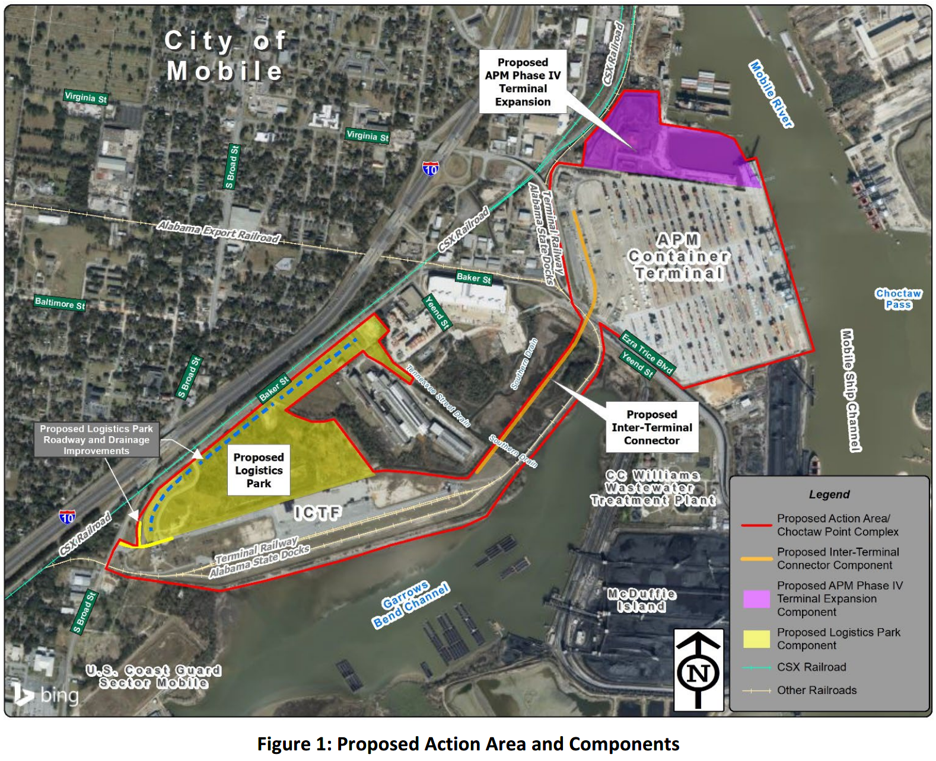
The Proposed Action Area is located within portions of Zone AE (100-year floodplain, base flood elevation 12 feet), Zone X (0.2 percent annual chance flood hazard; 500-year floodplain – also used to define the FFRMS Floodplain elevation per 24 CFR 55.2(b)(2 )), and Zone X (areas of minimal flood hazard) as identified on FEMA FIRM panels 01097C0566L (effective 6/5/2020) and 01097C0568L (effective 6/5/2020). In addition to the floodplains, portions of the Tennessee Street Drain within the Proposed Action Area have been designated as a regulated floodway by FEMA. The total area of floodplains impacted by this proposed action encompasses approximately 33 acres within Zone AE (100-Year Floodplain), 52 acres within Zone X Shaded (500-Year Floodplain), and 5 acres within a regulatory floodway.
A preliminary wetlands delineation of the project area has identified 22 isolated wetlands comprising 28.32 acres, including two tidal marshes. Three tidally influenced streams, one ephemeral channel, one open water, and four other waters totaling 18.66 acres were also identified.
Natural and beneficial functions of the floodplain that may be impacted include floodwater storage and conveyance, groundwater discharge or recharge, erosion control, water quality maintenance, and habitat for flora and fauna. Impacts of development can also affect recreational, educational, scientific, historic, and cultural values of the local community.
The geographic center of the project area is located at latitude 30.66 N, longitude 88.04 W in the city of Mobile, Mobile County.
There are three primary purposes for this notice. First, people who may be affected by activities in floodplains and wetlands and those who have an interest in the protection of the natural environment should be given an opportunity to express their concerns and provide information about these areas. Commenters are encouraged to offer alternative sites outside of the floodplains and wetlands, alternative methods to serve the same project purpose, and methods to minimize and mitigate impacts. Second, an adequate public notice program can be an important public educational tool. The dissemination of information and request for public comment about floodplains and wetlands can facilitate and enhance Federal efforts to reduce the risks and impacts associated with the occupancy and modification of these special areas. Third, as a matter of fairness, when the Federal government determines it will participate in actions taking place in floodplains and wetlands, it must inform those who may be put at greater or continued risk.
HUD must receive written comments by email on or before Saturday, July 13, 2024. The email address for comments is: Chuck.A.Melton@HUD.gov. HUD’s approving official is Karen A. Morris, Director, Birmingham CPD Field Office. A full description of the project may also be obtained for review by contacting:
Chuck Melton
Field Environmental Officer
US Department of Housing and Urban Development
Region IV Field Office
77 Forsyth Street SW
Atlanta, GA 30303
Phone: (678) 732-2133
Email: Chuck.A.Melton@HUD.gov

